Turtle Demo Activities

Complete the functions in TurtleDemo.java so that the following pictures appear. As you complete each function, uncomment the corresponding line in the main function:

1. smallSquare():

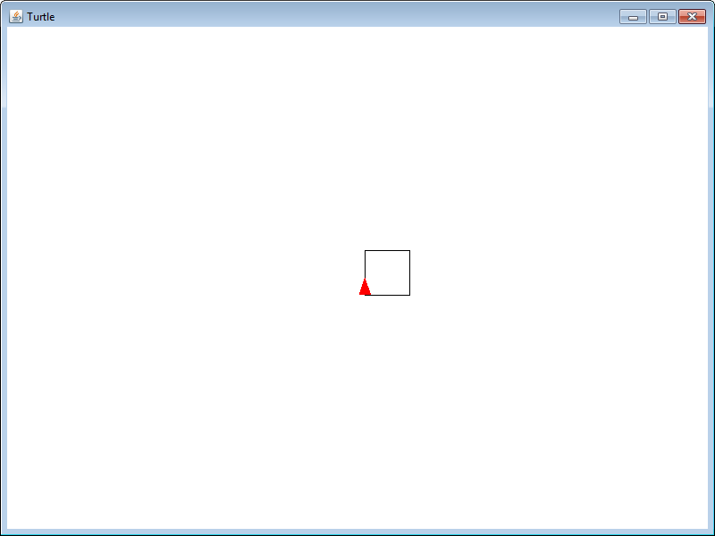

1. largeSquare():

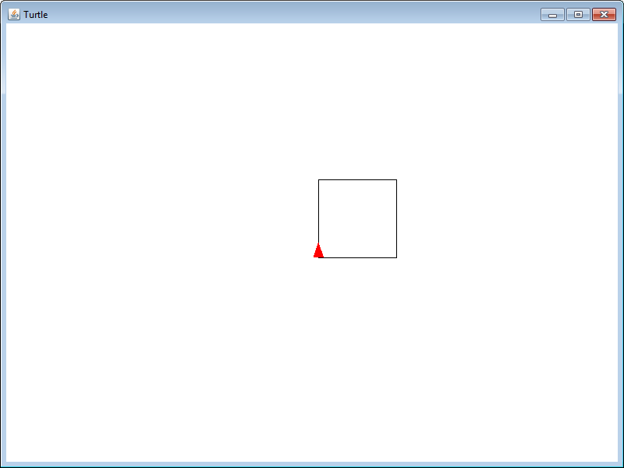

1. equilateralTriangle():

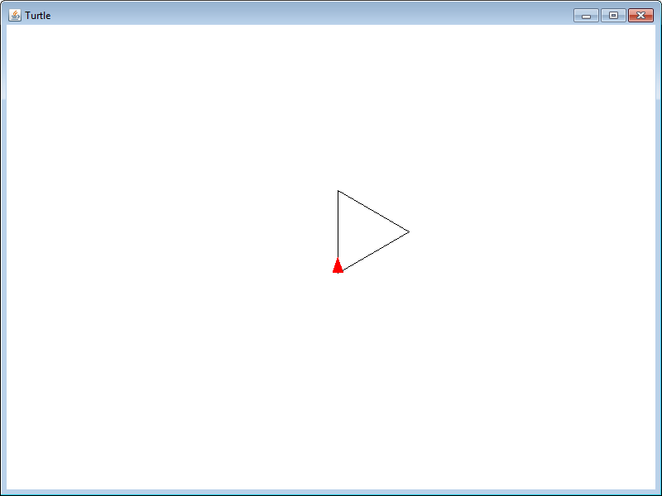

1. regularPentagon():

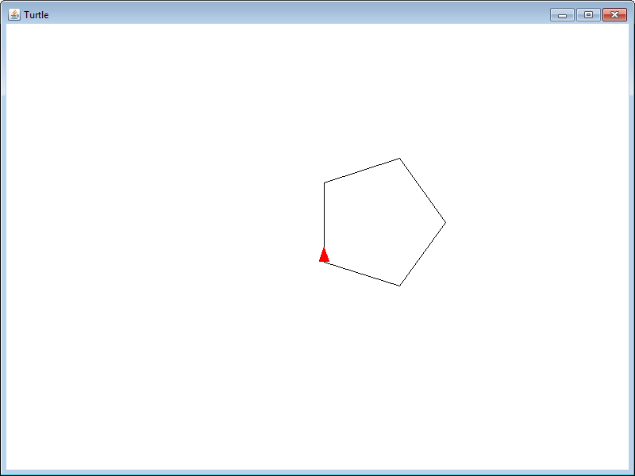

1. hypnoEyes():

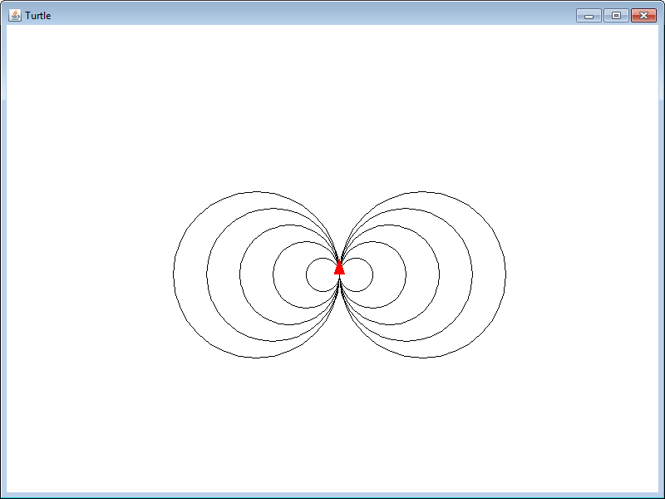

1. redCross():

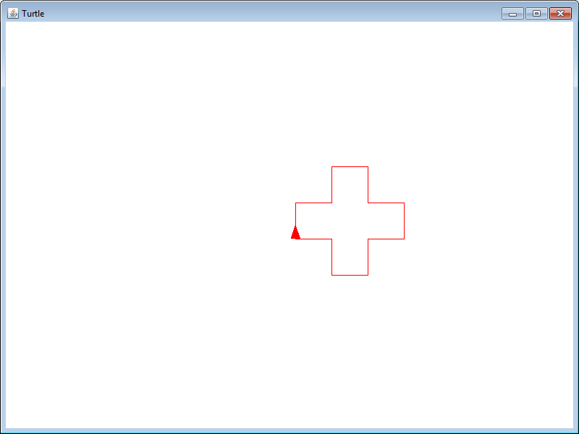

1. crescentMoon():

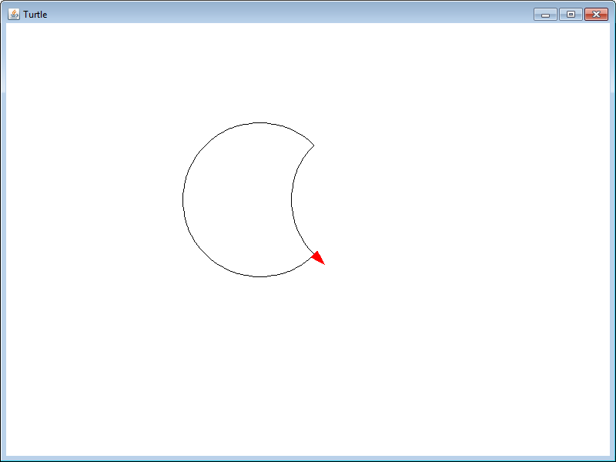

1. star():

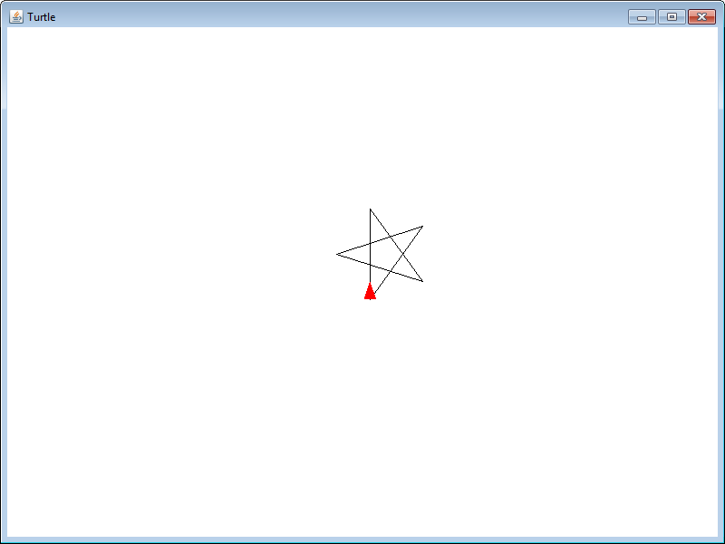

1. olympicRings():

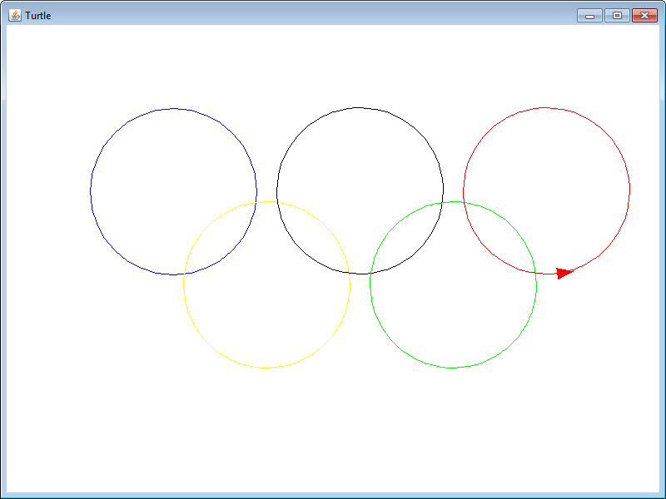

1. (BONUS) spiderWeb():

